# Knative Lab

https://knative.dev/docs/getting-started/about-knative-functions/

Installing:

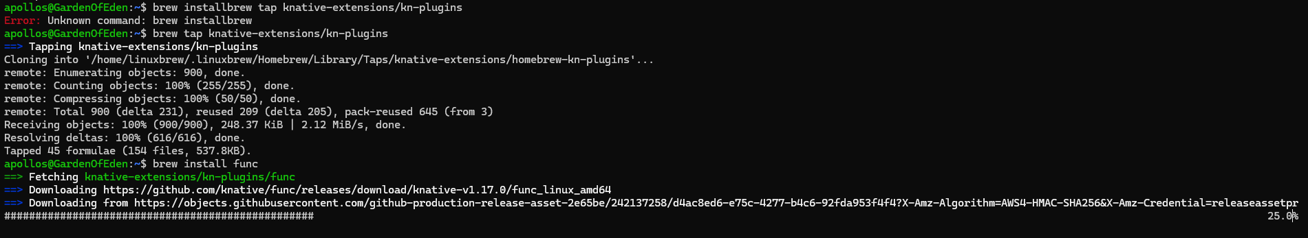

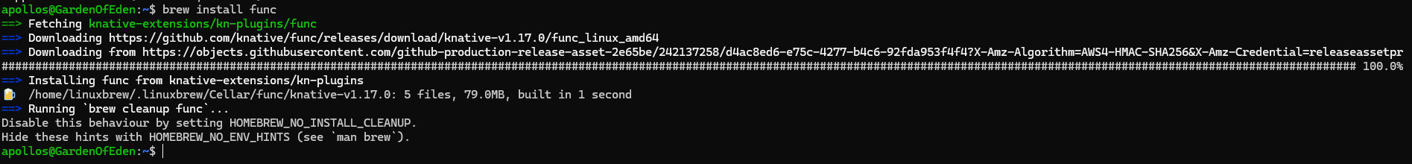

Creating a function:



Iinstalling KN:

